IMPROVING EYE CARE PATHWAYS FOR ADULTS WITH LEARNING DISABILITIES

A pilot study to review, improve and develop access to eye care for 37 adults with learning disabilities within South Devon

March 2007
INDEX

Executive Summary …………………………………………… 3

Introduction & Background ………………………………....… 4

Setting Up the Pilot Study ………………………………....… 5

Establishing the Eye Care Pathway ……………………....… 5

Preparation and Consent …………………………………….. 6

The Vision Screening Appointment …………………………. 6

Results …………………………………………………………. 7

Case Study …………………………………………………….. 9

Issues Identified in Implementing the Study ………………… 9

Recommendations ……………………………………………… 10

Conclusion ………………………………………………………. 11

Contacts ………………………………………………………….. 11

References ……………………………………………………….. 12

Bibliography ………………………………………………………. 13

Appendices ………………………………………………………... 15

- EXECUTIVE SUMMARY

1. Aim
This project was jointly funded by Teignbridge and Torbay Primary Care Trusts. The aim of the pilot study was to establish an accessible health and social eye care pathway for adults with learning disabilities within South Devon.

At a funding meeting in May 2006 this was revised to emphasise the importance of utilising and building upon primary care services with Optometrists and G.Ps wherever possible.

2.Objectives
The project objectives were to:

- Establish population figures for adults with learning disabilities within the South Devon area;
- Evidence the hidden population of adults with learning disabilities not receiving appropriate eye care locally;
- Make eye testing accessible to people with learning disabilities;
- Increase the uptake of primary eye care services;
- Identify incidence of referral / treatment interventions;
- Disseminate our findings

3. Results
Following the screening pilot, the results were as follows:-

- The majority of people were able to consent and participate in testing;
- Despite 16 (43%) already wearing glasses, a significant number of people were found to have visual problems. 30 (81%) were referred on as a result of vision screening;
- Issues identified in implementing the study included:
  - Lack of information / support for carers / key workers
  - Limited availability of accurate population data for adults with learning disabilities
  - Difficulties arranging hospital appointments
  - Need to ensure follow through of referrals
- Important links have now been established with relevant parties at all stages of the eye care pathway;
- Positive feedback

4. Recommendations / Service Development
- Cohesive eye care pathway for adults with learning disabilities needs to be established in the South Devon area;
- Primary eye care services should be used wherever possible;
- Maintenance of funding to ensure the Orthoptist can remain as a point of contact for anyone involved with the eye care of a learning disabled adult, and also to provide a vision screening service for those people with a profound learning disability unable to access primary eye care services;
- The Orthoptist to provide information and training for carers to highlight the importance of regular eye tests at the outside optician and a checklist of signs to indicate a possible visual defect;
- Liaison with Optometrists regarding assessment of adults with learning disabilities and development of referral paperwork to ensure continuity of care;
- Referral to the learning disability nursing team for de-sensitisation support for any person where anxiety prevents access to eye care services;
- Promote cohesive services for the learning disability population, by sharing information both locally and nationally.
B INTRODUCTION

Background

National research indicates that people with a learning disability have a higher incidence of visual impairment. Both Ellis (1986)¹ and Lewis (1994)² found that between 14-15% of learning disabled adults have a visual impairment severe enough to make them eligible for registration as blind or partially sighted.

The high incidence of sight problems increases dramatically with the severity of the learning disability and with age. Warburg (2001a) ³. Syndromes such as Rubella, Down’s and Cerebral Palsy are particularly prone to visual problems. Learning disabled adults will develop age-related eye conditions in much the same way as the general population. Records show that between 1930 and 1980 life expectancy for learning disabled adults rose from an average of 18.5 to 59 years. Lavis (1994)⁴. This trend is set to continue and therefore greater awareness of age – related eye conditions in this group is essential especially as people who are learning disabled generally experience these problems ten years earlier than the general population. College of Optometrists (2000)⁵

The RNIB has noted that these changes often go unnoticed or are incorrectly attributed to the worsening of an individual’s general condition, / onset of dementia.

Warburg (2001b)⁶ also reports that the most widespread eye condition for people who are learning disabled is cerebral visual impairment and that optic atrophy, high myopia, cataracts and keratoconus are also very common. A large proportion of individuals will have more than one of the above.

In Devon, cross referencing the learning disability register with the register of blind and partially sighted people, found that of 1,866 people with a learning disability only 34 were registered as visually impaired. i.e. 1.82%. It was clear that under registration was occurring. This was effectively blocking access to rehabilitation services via the CVI. (Certificate of Vision Impairment) Skilton (2003)⁷

It is well recognised that visual impairment can have a profound impact on a person’s ability to communicate and be independent. Undetected visual errors often lead to loss of mobility, behavioural problems due to frustration, lack of stimulation, and in some cases blindness. RNIB state that “people’s quality of life can be greatly improved when their sight problems have been identified and they receive appropriate help to take control over their lives”.

At present children with learning disabilities are monitored regularly by Orthoptists within the school setting. Once an individual reaches 19 however, there is a significant risk that their continuity of care can become very disjointed as child support mechanisms no longer apply.

The Department of Health White Paper “Valuing People A New Strategy for Learning Disability for the 21st Century” 2001⁸

This White paper sets out four key principles:
- Rights
- Independence
- Choice
- Inclusion.

Objective 5 relates to Good Health:

- To enable people with learning disability to have access to health care designed around their needs with fast and convenient care delivered to a consistently high standard and with additional support where necessary

Organisations such as RNIB, Sense, Mencap and more recently SeeAbility have all published reports highlighting the problems faced by learning disabled adults with a visual impairment.

“No one is too disabled to have his/her sight tested” RNIB (2000)⁹

C SETTING UP THE PILOT STUDY

Approximately two years ago following previous unsuccessful bids to fund a large research project in this area. A small multi-disciplinary team from health and social care, investigated the need for ethics approval (see appendix A) and made a successful bid for funding from Teignbridge and Torbay Primary Care Trusts to carry out a small pilot study to screen 37 adults with learning disabilities and improve the eye care pathway. The aim was to develop a service that could then be used in other areas to promote the recommendations as outlined in The Department of Health White Paper “Valuing People”.

FINANCE

Our grant of £14,000 was used to:

- Partially fund the Orthoptist’s extended role 0.2wte term time only.
- Purchase equipment and carry out vision screening
- Cover the cost of time and travel for training purposes for the Orthoptist e.g. meeting with Margaret Woodhouse at Cardiff University and Gill Levy at RNIB, both experts in this field, Total Communication training and observation of low vision clinics and the work of Rehabilitation Officers for the visually impaired.(Rovis).
- Administration costs including the preparation of user friendly paperwork.
- To produce a final report and disseminate our findings

An important fact highlighted by this study is that much of the input required to develop this service is already within the working remit of enablers, key workers, community nurses and Rovis.

ESTABLISHING THE EYE CARE PATHWAY

THE TEAM

Our team consisted of the Practice Manager for Devon Adult and Community Services Sensory Team (who had already written a paper on visual impairment and the unmet need within the local population of adults with learning disability), a Speech and Language Therapist for Learning Disability, an Orthoptist and Lead Nurse for the Learning Disability Team.

The Consultant Ophthalmologist who is also Chair of the local Low Vision Services Committee, acted as advisor.

The make up of the above team made inter – agency working a necessity and provided a wealth of expertise and advice.

THE STUDY SAMPLE GROUP

To give detailed attention to all stages of the pathway, a small sample of 5% of the total local population of 724 was selected to give 35 participants who would be tracked from initial eye test through to registration if appropriate.

The participants had a broad range of ability and age, with the emphasis on the older age group with at least 1/3 over 40 years old to ascertain whether age related eye conditions are detected in this group.

- Age range 22 – 80 years. Average age 46 years.
- 18/37 (49%) male 19/37 (51%) female

PREPARATION AND CONSENT

Information using easier words, symbols and photos to explain what happens during an eye check and an invitation for an appointment were sent to individuals and their carers. (see appendix B) Follow-up phone calls were made and individual sessions offered with the community team healthcare assistant to help people understand what happens during an eye-test and give informed consent, if possible. A combination of photos of vision screening, fixing a light source and having one eye covered was used. (see appendix C) Talking Mat materials were also produced to use if necessary.(see appendix D) Those people who could read words and/or recognise symbols signed a simple consent form.(see appendix E) This Total Communication approach was planned with the help of a speech and language therapist.

For those people who have little or no verbal or symbolic language, interpretation of body language by a familiar carer/support worker during each stage of the assessment was used to gauge consent or refusal. The assessment continued or ended accordingly.

Many anecdotal comments reported how useful this process was. 87% of people seen were able to co-operate with testing well, the remaining 13% were able to partially participate and require domiciliary follow up. No-one found testing impossible.

DE-SENSITISATION

For some individuals requiring referral appointments following screening, further de-sensitisation was provided by learning disability nurses. This has involved support in a range of ways depending on the individual’s needs, including prior to and during hospital visits and to access community diabetic retinal screening.

THE VISION SCREENING APPOINTMENT

VISION

.This was assessed for near and distance, with both eyes open and each eye separately with their most recent spectacle correction where available. Methods used varied from objective methods using forced choice preferential looking techniques such as Keeler Acuity Cards and Cardiff Acuity Cards, to subjective methods using picture recognition with 3m Crowded Kay Pictures and letter matching using Keeler 3m Crowded LogMAR.

Near vision was assessed using Kays Crowded Near Vision Card.

Where formal visual acuity testing was not possible the Orthoptist used a combination of brightly coloured silent objects combined with observation of visual behaviour and information regarding a person’ s functional vision from the carer/key worker.

OTHER TESTS

Cover Test – To assess for the presence of squint.
Ocular Movements – To assess for the presence of any abnormalities of eye movement and to observe any signs of nystagmus.
Eye Health – To observe the lids and lashes, for any signs of redness, infection or irritation. To check the pupil reactions to light and attempt to gain a red reflex to exclude serious eye conditions such as retinal detachment and cataract.
If no squint is detected - Binocular functions are confirmed where possible .
Where a squint is detected - Measurement of the angle.
Confrontation Fields – To detect any obvious field defect.

At the end of each session the Orthoptist sent a user friendly report to each person who had been tested, with copies for carers and for an individual’s health records, plus a copy of my full assessment to the person’s G.P and the local Optometrist / Ophthalmologist where referral on was indicated. An outcome form was also included for all referrals (see appendix F) so that the Orthoptist could monitor a person’s progress along the eye care pathway, and the effectiveness of the screening programme. For flow chart of pilot study eye care pathway (see appendix G)

D RESULTS

Results confirm the research finding that learning disabled adults experience a much higher incidence of visual defects and significantly lower uptake of eye care services. Up take of services increased dramatically as a result of our study.

Total number of people referred following screening 30/37 (81%)
- 17/37 (46%) were referred to primary care.
- 14 (38%) to the high street Optometrist.
- 3 (8%) to the G.P.
- 8/37 (22%) were referred to secondary care.
- 5/37 (13.5%) will require Orthoptic domiciliary review in two years time.
- Following my initial referral to primary care 4/17 (23%) were referred on to secondary care via the GP/Optometrist.

It is recognized that people with Down’s Syndrome experience a very high incidence of visual problems and age related conditions often occur at a much earlier age.
- 9/37 (24%) of people screened had Down’s Syndrome.

SPECTACLES

- 16/37 (43%) already had glasses. Of those 16, 5 weren’t wearing them.
- As a result of screening of the 14 referred to the Optometrist, 6/14 were prescribed new glasses. This included 3 people who were given reading glasses for the first time. Their age ranged from 41 to 71 years.
- 5/37 (13%) have been referred to the local Community Learning Disability Nursing Team, who provide intensive de-sensitisation where necessary to aid access to services and help with issues such as encouraging glasses wear.

REGISTRATION
- Prior to screening 0/37 (0%) were registered as blind or partially sighted.
- 3/37 (8%) are now registered as a result of the screening programme.

The presence of some conditions mean that vision will always be reduced and may even continue to deteriorate, it is for this reason that registration and referral to a Rovi is important.
REFERRAL TO ROVIS

Prior to screening 0/37 were accessing support services via Rovis
- 4/37(11%) have now been referred to the Rovis

We have received considerable positive feedback from both participants and their carer’s regarding the pilot study. There have been many instances of carers commenting on improved interaction / independence following the eye assessment.

CASE STUDY

Ella* is a 47 year old female. Her parents reported concerns that she was holding objects very close and that she had cataracts. She had no glasses. On testing her left vision was fair/poor and her right vision was extremely poor such that she had no light perception.
She had a marked right squint and an obvious right cataract .

She was referred for further tests and after discussions she was listed for an investigation under anaesthetic and right cataract extraction if appropriate. It transpired that Ella had had a childhood squint in the left eye and this had resulted in lazy left vision or amblyopia. She then developed a cataract in that eye which had been removed in 2001 however because of the left amblyopia although the vision improved a bit it was still reduced. Ella therefore had to rely on the vision in her good right eye, however as the cataract started to develop in her right eye her vision with both eyes open rapidly began to deteriorate but it wasn’t until she was screened that Ella was referred for the second cataract. Following removal of the cataract in her right eye and a lens implant, she now has vision of 3/9.5pt which is just below normal levels.

* Name and identity protected.

ISSUES IDENTIFIED IN IMPLEMENTING THE STUDY

- Confusion among care staff as to who did and didn’t wear glasses
- Problems locating glasses
- Not using the correct glasses for near and distance tasks
- Not using the most recent prescription.
- Dirty lenses, ill fitting, uncomfortable frames.
- Lapsed, irregular eye tests and non follow through of eye care appointments
- Un-recorded concerns regarding deterioration of functional vision.
- Lack of advice and support for adults being cared for at home.
- Obtaining accurate population data for learning disabled adults within the area.
- Making hospital appointments can be difficult. This is compounded for adults with learning disabilities, who may require an appointment when the waiting area is relatively quiet.
- This study has also highlighted a number of elderly carers where arranging complex appointments becomes difficult due to their own disabilities.
- Ensuring that referrals are followed through.

OPTOMETRISTS
Primary care optometrists will play a key role in the proposed eye care pathway and their response during our study was extremely encouraging, however the service will require:
- Optometrists to complete a form outlining any prescription with details of when the glasses should be worn and an outline of any pathology found
- Assessing learning disabled adults may require extra time, including completing the feedback forms. This will have funding implications and is being investigated at a National level.
- Optometrists may lack confidence and equipment to assess this group. (Mencap 1998, ¹⁰ Adler et al.2005, ¹¹ Woodhouse 2000, ¹² SeeAbility 2006 ¹³)

E RECOMMENDATIONS

The key factor has been an Orthoptist who co-ordinated all of the eye and social care pathway for learning disabled adults to achieve the best visual outcome. The following are recommendations from the study team.

- Primary eye services should be used wherever possible.

- Maintain funding for the Orthoptic co-ordinator role. (currently 0.2wte term time only).

- Provide information for all adults with a learning disability and their carers about the importance of an annual eye test, the main signs and symptoms that can be indicative of a visual defect and practical advice on glasses use, lighting and contrast.
- Provide a list of eye care contact numbers and a co-ordinator number if difficulty accessing eye care is experienced.
.
- Provide Information and training for primary care groups to raise awareness of the importance of regular eye tests for all learning disabled adults

- Dedicate clerical time for:-
- Sending information leaflets.
- Acting as a point of contact for hospital eye appointments
- Co- establishing and maintaining a database for adults with learning disabilities by utilizing the G.P. Read data base.

- Fund an Orthoptist skilled in working with people with a learning disability to carry out a domiciliary assessment where access to primary services was not possible. In the study, 13 % of people fell into this category.

- Promote via learning disability teams de-sensitisation sessions, to aid access to and uptake of eye care services. This has already had a huge impact by allowing several people in the study to access primary services successfully for the first time.

- Raise awareness amongst eye care professionals of the importance of referral on to Rovis and low vision services and /or registration wherever corrected visual acuity is found to be reduced with both eyes open and a significant deterioration in functional vision has been noted, particularly where this leads to a reduction in independence.

- Promote cohesive services locally for the adult learning disability population, by sharing information across the Primary Care Trust, Adult Community Services, Learning Disability Partnership Board, the local Low Vision Services Committee and the Local Optical Council.

- Promote cohesive services nationally, by sharing information with RNIB,Seeability,Low Vision Services Implementation Group and other relevant agencies.

CONCLUSION

The aim of this study has been met in establishing an eye care pathway for adults with learning disabilities, which meets the requirements of the government white Paper Valuing People 2001 and provides a model which can be used elsewhere.
We have received considerable positive feedback from both participants and their carer’s regarding the study. (see appendix H). There have been many instances of carers commenting on improved interaction / independence following the eye assessment.

CONTACTS

Kathy Diplock, Orthoptist, Torbay Hospital. kathy.diplock@nhs.net
Char Smith Professional Lead for Speech and Language, Devon Learning Disability Trust.
Kate Skilton Practice Manager, Devon Adult and Community Services Sensory Team. Kate.skilton@devon.gov.uk

REFERENCES

1. Ellis D. (1986) Editor Sensory Impairments in Mentally Handicapped People. Croom Helm.

2. Lewis A. (1995) Investigating the Needs of people with a Learning Disability and Visual Impairment: Kent Association for the Blind. RNIB Focus 15, 17-18.

3. Warburg M (2001a) Visual Impairment in adult people with intellectual disability: Journal of Intellectual Disability Research 45 (5),424-438.

4. Lavis D. (1994) One Step Ahead: Aspects of sensory impairment and the ageing process. RNIB Focus 13, 1-2.

5. College of Optometrists. (2000) The Care and Management of Patients with Learning Disabilities.

6. Warburg M. (2001b) Visual Impairment in adult people with moderate severe and profound intellectual disability. Acta Ophthalmology Scand 79, 450-454.

7. Skilton K. (2003) An evaluation of the equity of access to visual rehabilitation training for visually impaired adults with learning disability in Devon. MSc paper, Birmingham University.

8. Department of Health. (2001) Valuing People: A strategy for learning disability for the 21st century. (DOH CM5086).

9. RNIB. (2000) Focus Factsheet: Access to eye care for adults with learning difficulties.

10. Mencap. (1998) The NHS: Health for all? People with Learning Disabilities and Health Care.

11. Adler P, Cregg M, Duigan A, Ilett G & Woodhouse JM. (2005) Effect of training on attitudes and expertise of optometrists towards people with learning disabilities. Ophthal. and Physiol.Optics 25 105-118.

12. Woodhouse JM, Griffiths C & Gedling A. (2000) The prevalence of ocular defects and the provision of eye care in adults with learning disabilities living in the community. Ophthal. and Physiol. Optics 20 (2) 79-89.

13. Seeability. (2006) Seeability’s reponse to the Review of General Ophthalmic Services.

BIBLIOGRAPHY

1. Aitken S & Buultjens M. (1992) Vision for Doing: Assessing functional vision of learners who are multiply disabled. Sensory Series number 2.
Moray House.

2. Department of Health. (2001) Seeking Consent: working with people with learning disabilities. (DOH 25754).

3. Collins J,& Skilton K. (2004) Low vision services in South Devon, a multi agency, multi disciplinary approach. Ophthal. and Physiol. Optics 24 335-355.

4. Frankel J & Halls B. (1993-1997) Phase1 and Harvey F. Phase 2, Sensory impairment project. Invicta Community Care (NHS) Trust. 7-9 and 31-42.

5. Fyson R & Ward L. (2005) Making Valuing People work: Strategies for change in services for people with learning disabilities. Pub. By The Policy Press.

6. Howells G. (1990) Primary care for people with a mental handicap – report of working party on the interface between the primary care team and people with a mental handicap: Occasional paper 47 Pub. by The Royal College of general Practitioners. Chapters 3 & 7.

7. Kerr M, Fraser W & Felce D. (1996) Primary healthcare for people with a learning disability: A keynote review. British Journal of Learning Disabilties 24 (1) 2-8.

8. Kerr M. (1998) Primary healthcare and health gain for people with a learning disability. Tizard Learning Disability Review Vol.3 issue 4.

9. Low Vision Services Implementation Group. (2005) Sub group for people with learning disabilities: The Bold Guide to learning Disabilities.

10. Mencap. (1997) Prescription for change.

11. McConnell L. (2005) Eye care and learning disability: Stepping Out New Beacon 22-25.

12. McCulloch D, Sludden P, McKeown K & Kerr A. (1996) Vision care requirements among intellectually disabled adults: A residence based pilot study. Journal of Intellectual Disability Research 40 140-150.

13. Pharoah P, Cooke T,Johnson MA, King R & Mutch L. (1998) Epidemiology of cerebral palsy in England and Scotland. Archives of Disease in Childhood: Foetal and Neonatal Edition.

14. RNIB. (2006) Focus Newsletter. Jan.issue 43.

15. Torbay Council & Torbay NHS Care Trust. (2006) Seeing Sense in Torbay: Information for people with sight loss.

16. van Splunder J, Stilma JS, Bernsen RMD & Evenhuis HM. (2006) Prevalence of visual impairment in adults with intellectual disabilities in the Netherlands: Cross-sectional study. Eye 20 1004-1010.

17. Willis A, Dracup M & Starling S. (2004) “Right to Sight” Accessing eye care for adults who are learning disabled. Manchester Learning Disability Partnership & Community Orthoptic Service.

18. Woodhouse JM, Adler P & Duigan A. (2003) Ocular and visual defects amongst people with intellectual disabilities participating in Special Olympics. Ophthal.and Physiol.Optics 23,221-232.
APPENDIX A: CLARIFICATION REGARDING ETHICS APPROVAL

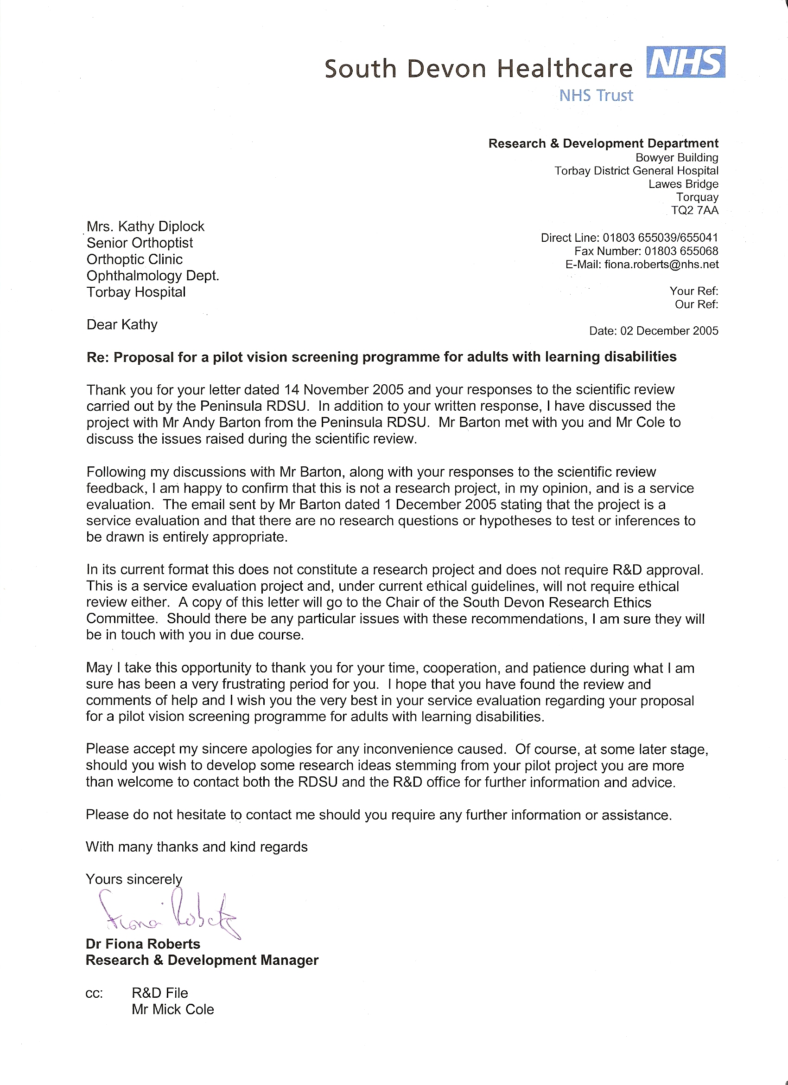


APPENDIX B: USER FRIENDLY PAPERWORK

1. INFORMATION LETTER

Vision screening pilot for 37 adults with Learning Disabilities Ver.1

Dear ………………………………Carer ………………………………

My name is Kathy Diplock and I am an Orthoptist I test people’s eyes to check they can see.

Many people with Learning Disabilities have problems seeing. Few people get their eyes tested.
In Teignbridge and Torbay we want to find out if this is true.

I would like to test your eyes to make sure they are O.K.

I can help you find someone who can help if you have an eye problem.

I am part of a small team and we want to make sure you get the chance to have an eye test every two years.

We need to use the information about your eyes to tell other people. We will not use your name when we write our report.

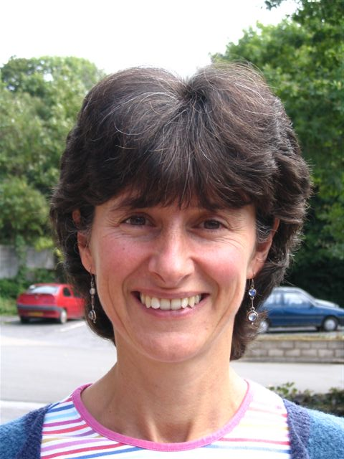
If you have any questions about our project please contact us.

Kathy Diplock
Torbay Hospital.
Telephone: 01803 655122.

2. INVITATION LETTER

Vision screening pilot for 37 adults with Learning Disabilities Ver.1

Dear …………………………………… Date: ……/……/…………
Can you see well?
Do your eyes hurt?
Do you want an eye test? | 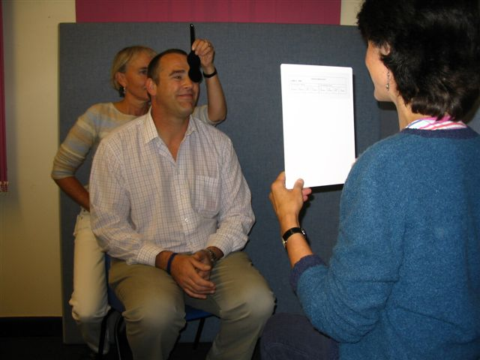

My name is Kathy Diplock and I am an Orthoptist I test people eyes and what they can see.
If I find a problem I will tell you who can help.
These pictures/photos show what will happen in an eye test.
Please send me the sheet, About Your Eyes in the stamped addressed envelope.
If you already have glasses please bring them with you.

If you have any questions you can ring the Community Learning
Disability team on the Telephone. 01626 216260.

Hope to see you soon,
Kathy Diplock.

3. PREVIOUS HISTORY LETTER

Vision screening pilot for 37 adults with Learning Disabilities VER.1
ABOUT YOUR EYES

FULL NAME
ADDRESS & POSTCODE
TELEPHONE NUMBER
DATE OF BIRTH
G.P.'S NAME & ADDRESS
GENERAL HEALTH/MEDICATION
Please circle where appropriate
Has the person had a visual problem (e.g. glasses) before? Y/N If yes, please give details of when and what: ………………………………………………………………………………………………………………………………………………………………………………………………………

Is there a visual problem now? Y/N
If yes, can you describe the problem now: Y/N
E.g. Holds object near to face Y/N
Holds object far away Y/N
Drops things regularly Y/N
Bumps into things Y/N
Has difficulty seeing in daylight/bright light Y/N
Has difficulty seeing small objects Y/N
Has eye ache / headache Y/N
Other: please state: ………………………………………………………………………………………………………………………………………………………………………………………………………

Visual behaviour: are any of the following present?
Finger flicking in front of eye Y/N
Eye poking Y/N
Unusual head position when looking intently at objects Y/N

Anything else that could indicate a visual problem?
E.g. prefers music/sound to T.V./looking at pictures Y/N
Makes noises repeatedly e.g. humming Y/N

Other: please state: ……………………………………………………………………………………………………………………………………

Thank you for taking the time to complete this form. This will help to reduce the time required for the usual assessment.
If you already have glasses please bring them with you.

Signature of person/carer

4. I TESTED YOUR EYES.

Dear …………………………………… Date ……/……/…………
TODAY I TESTED YOUR EYES | ☒ | ☑

 | You can see well
 | Your eyes looked straight
 | One eye turns (squint) in or out
 | It was difficult for you to see
 | Your eyes looked sore
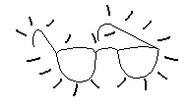 | You may need new glasses

You need to see the ophthalmologist (eye Doctor) at Torbay
Hospital. The eye Doctor will do more tests about the Health of
your eye.

You need to go to the optician for more eye tests and for glasses.
If you have glasses bring them with you.

APPENDIX C: DE-SENSITISATION PHOTOS

Vision screening pilot for 37 adults with Learning Disabilities Ver.1

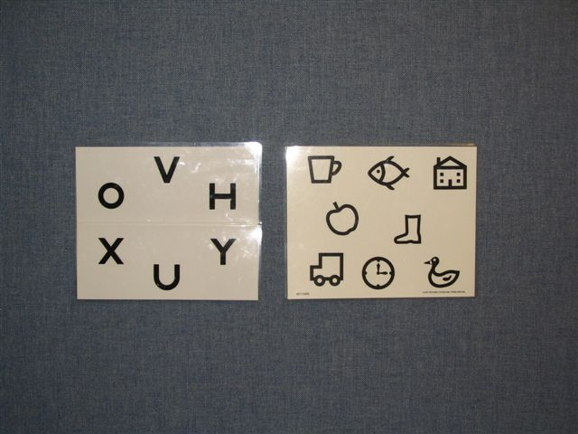 | 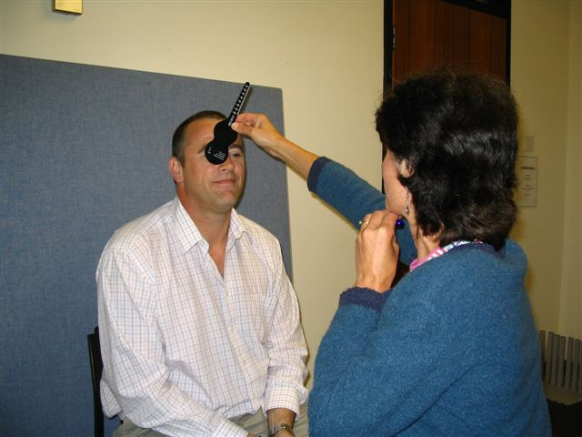
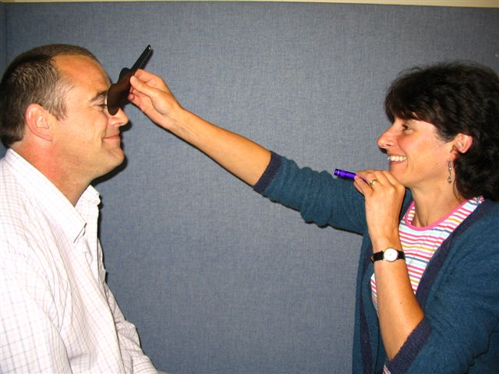 | 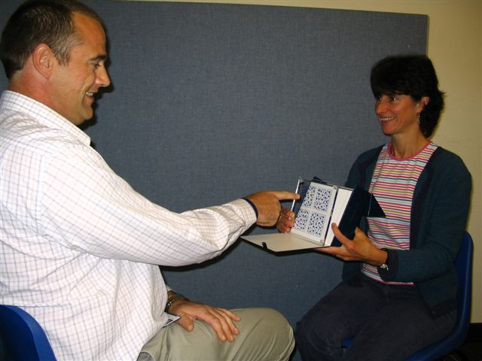
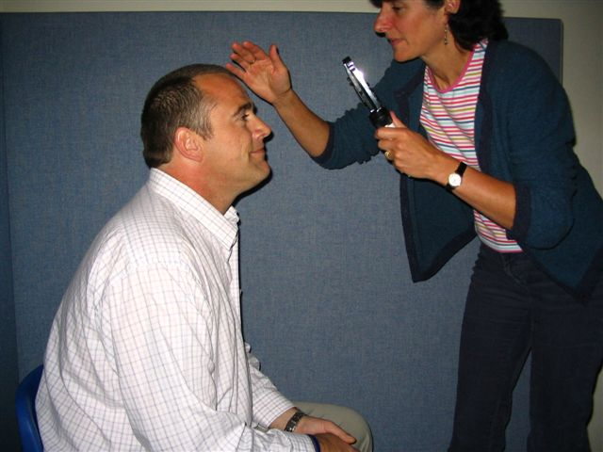 | 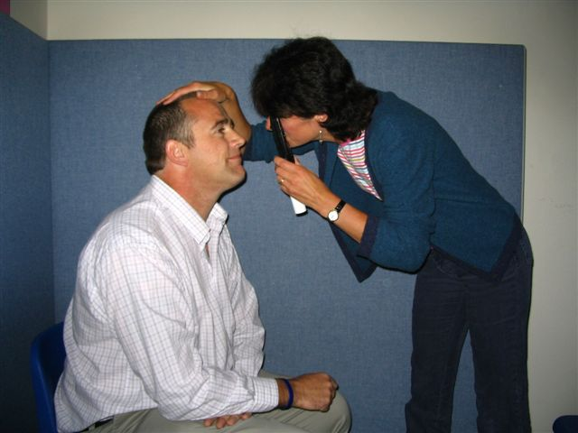
 | 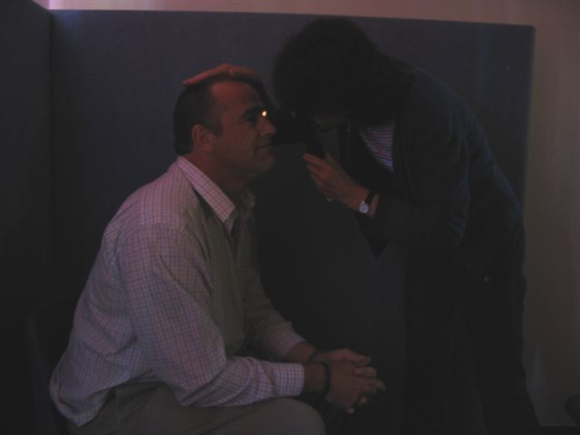

APPENDIX D: TALKING MAT INFORMATION

Consent for Vision Assessment

- Between 50% - 90% of people with learning disability have difficulties with communication (Foundation for People with Learning Disability: Fundamental Facts 2000)

- To ensure a wide ability range of people can be included in this pilot, a Total Communication approach will therefore be used. This means using simple words; keeping what is said short; going at the person’s pace; and showing the main meaning alongside speech using objects, signing, photos, pictures and/or symbols, depending on what an individual can understand or use;

- Talking Mats will be the primary tool used to gain consent.

What is a Talking Mat?
A Talking Mat is an interactive resource that uses 3 sets of photos or picture symbols. We have adapted these as follows:
1. The Topic - Eye Test
2. Options - What this means
3. Visual Scale – Symbols showing: Yes; Maybe; No

How do Talking Mats work?
The person is given the ‘options’ one at a time, asked to think about how s/he feels and to place the photo or symbol under the appropriate Visual Scale symbol, (eye-pointing can also be used). A photograph is taken of the completed mat as a record of the conversation showing what the person consents to and what is of concern or not consented to. Each concern can then be further explored if necessary. Below is an example of a completed Talking Mat.
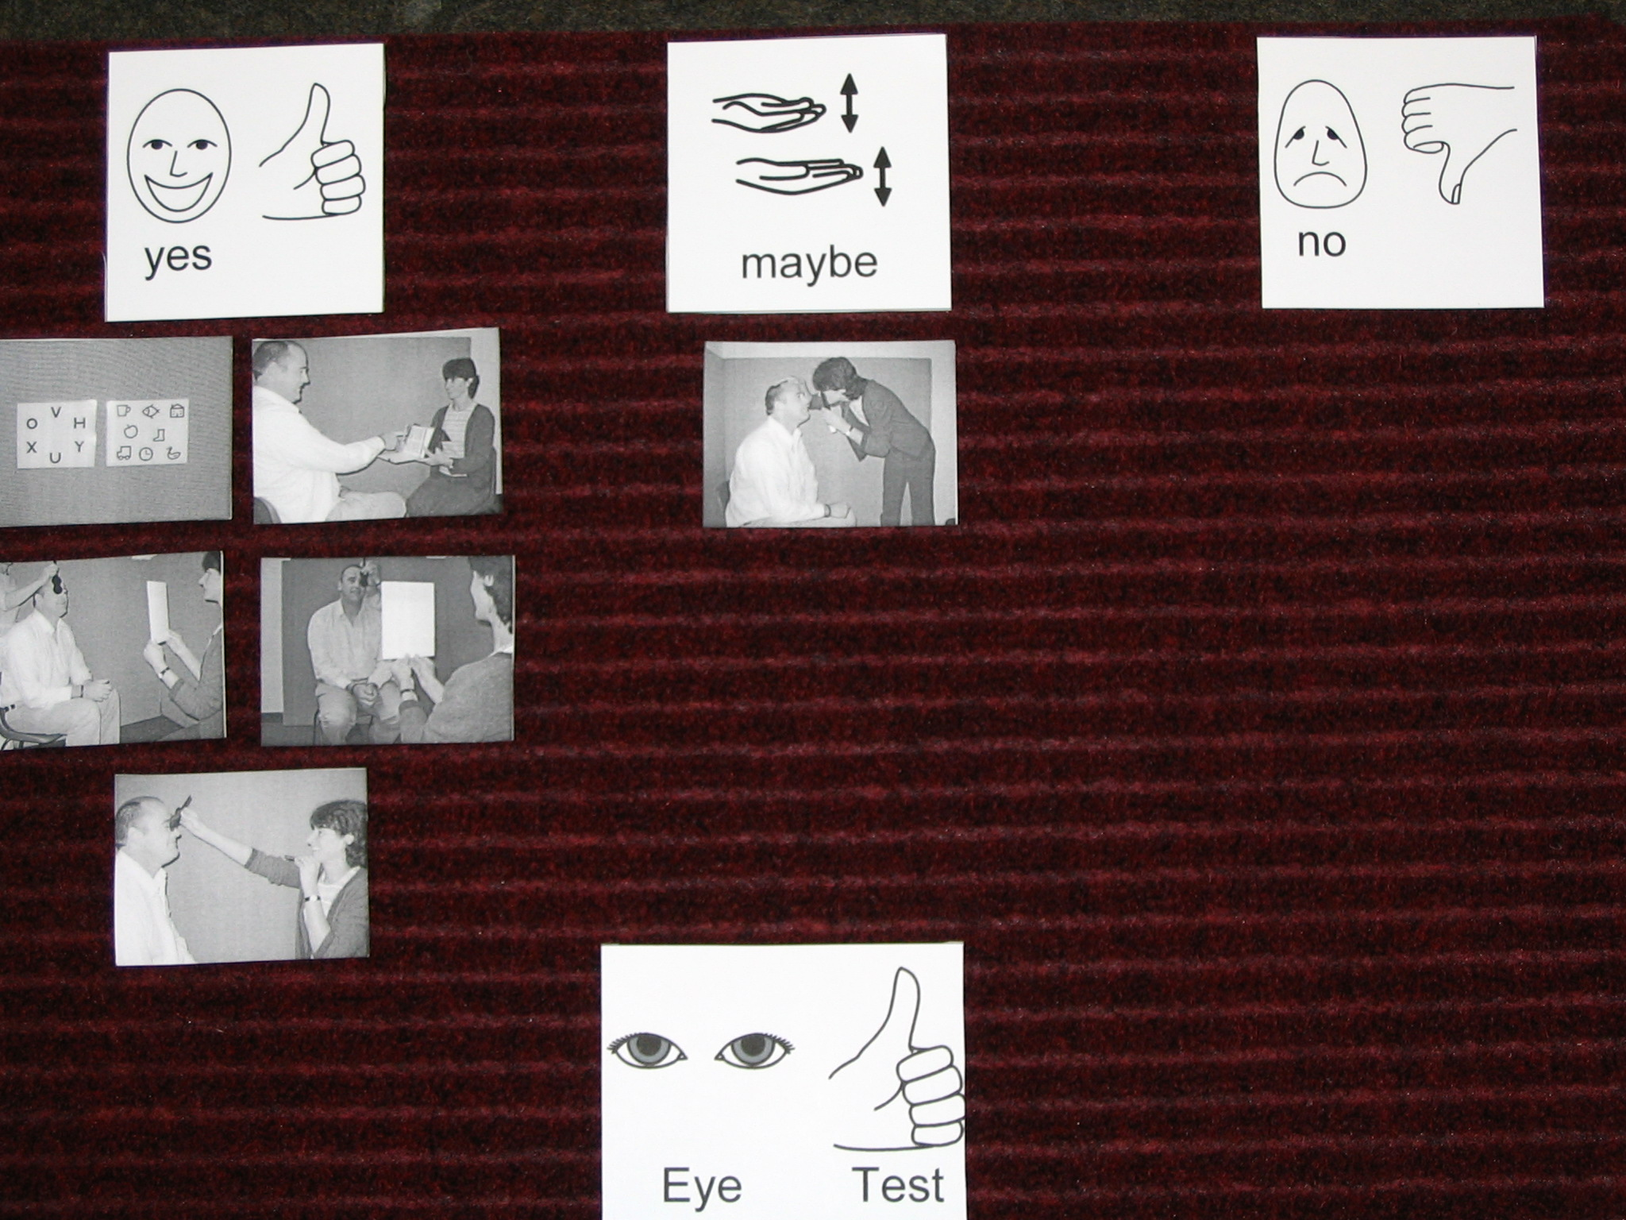

APPENDIX E: CONSENT FORM

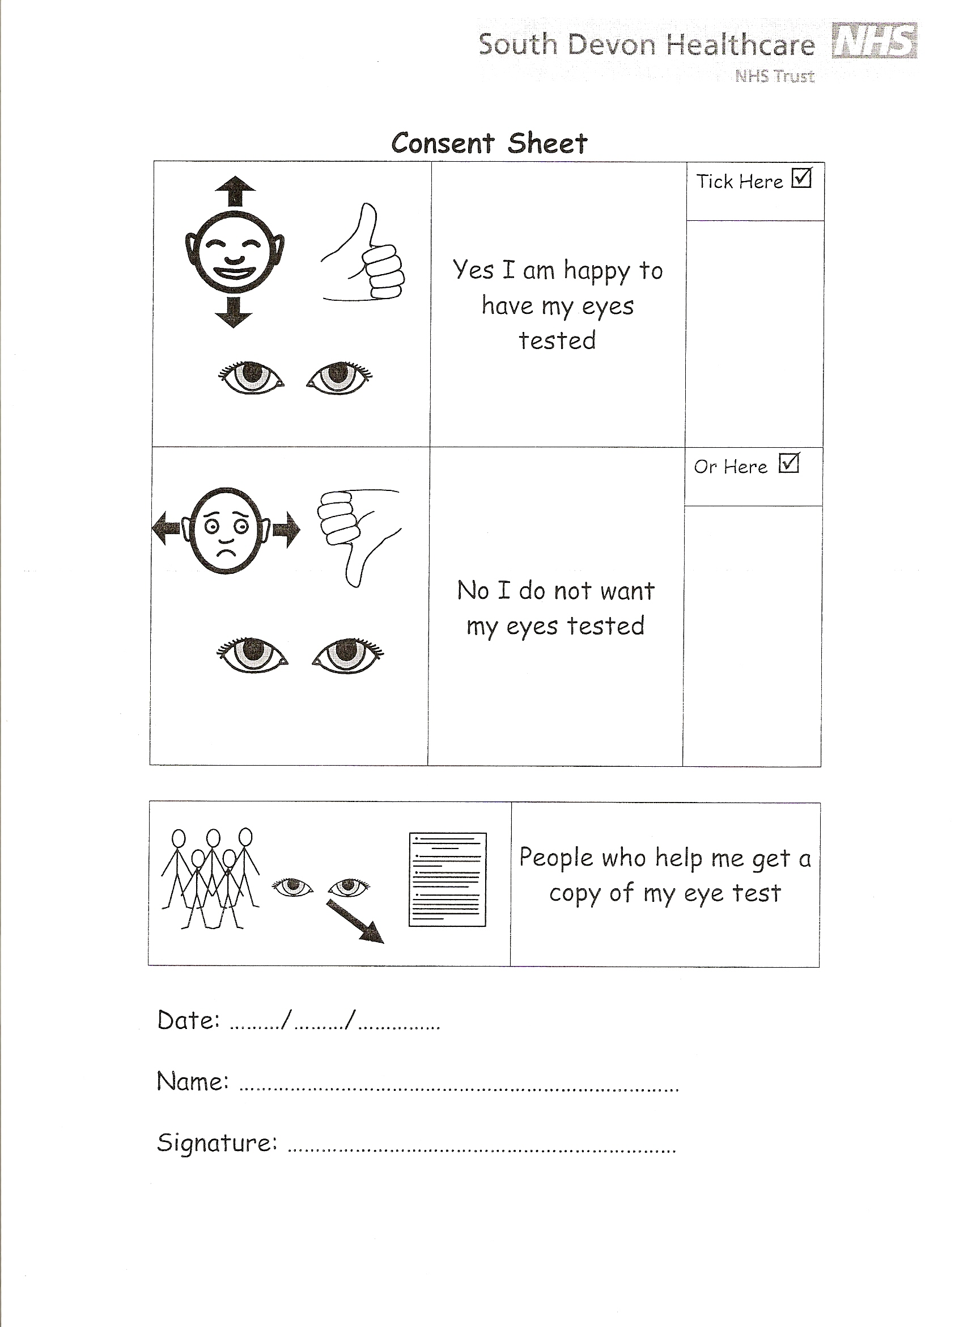
APPENDIX F: OUTCOME RESPONSE FORMS FOR HES / OPTOMS

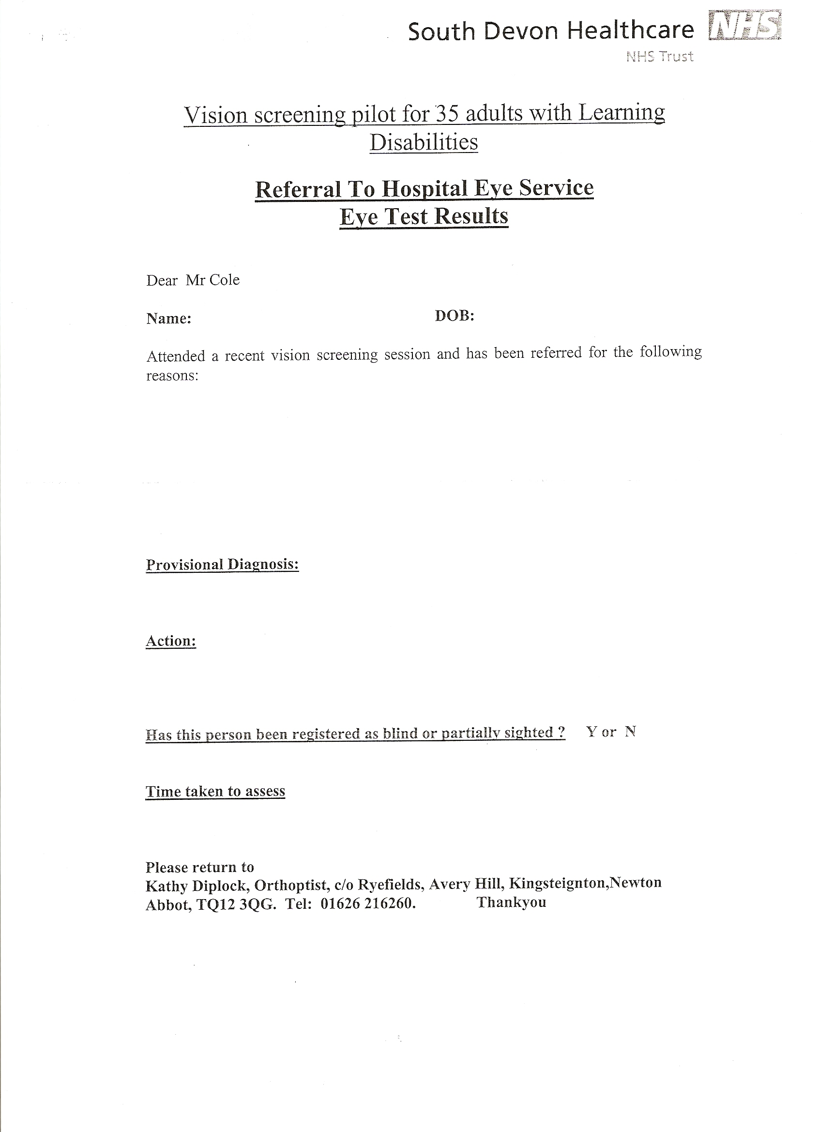
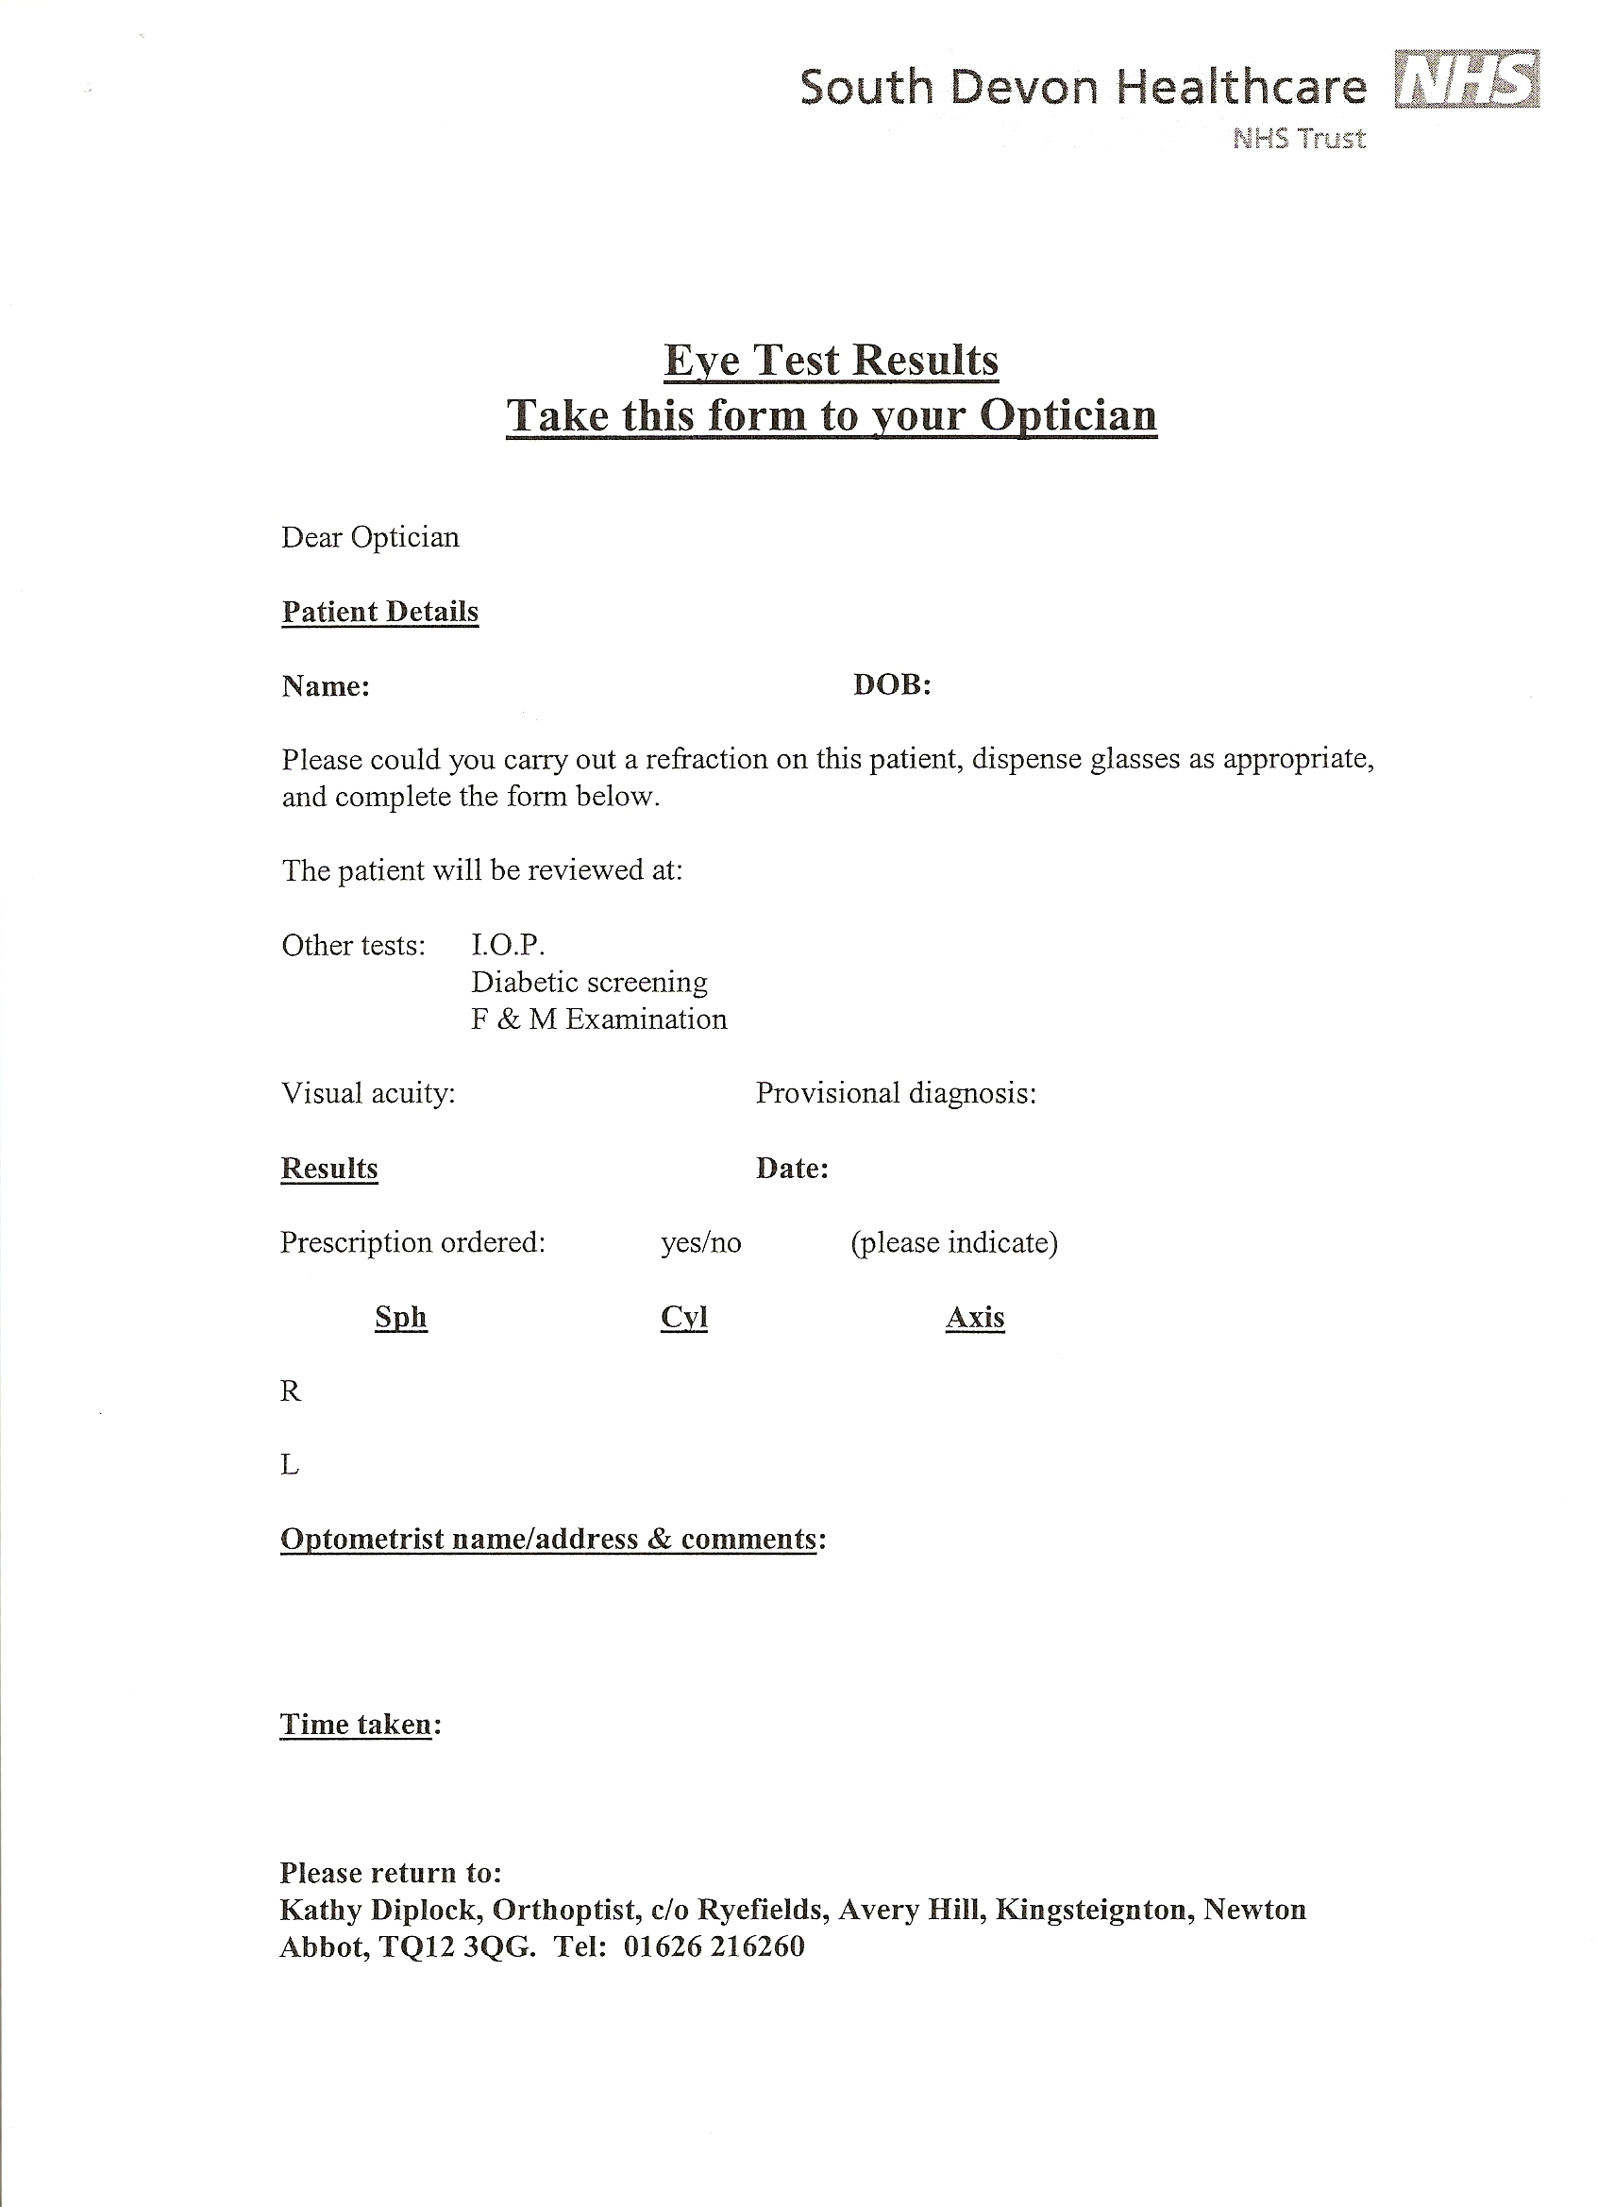
APPENDIX G: PILOT STUDY FLOW CHART

TEIGNBRIDGE PILOT

De-sensitisation programme to facilitate access via the Learning Disability community nurses/other team members.

Vision Screening by Orthoptist

Referral Options
Refer for de-sensitisation
with learning disability nursing team
where necessary

Primary Care
- High Street Optometrist

Recent glasses test. Confirm and update records. Ensure follow up appointment
Primary Care
(b) G.P.
Domiciliary

Secondary Care
H.E.S
- Outpatients
- Inpatients

(b) GP

Registration
If appropriate
Social Services
Rehab. Officer for Vis. Impairment (Rovi)
Low Vision Clinic

APPENDIX H: PARTICIPANT FEEDBACK

We used Participatory Approaches to find out what 12 out of the 37 people who had their eye-sight screened thought and felt about the experience, and what difference good eye-sight makes to their lives. This involved drawing, looking at equipment and material used and peoples’ comments being recorded.

Here are some of the pictures people drew showing ‘a good day’, ‘what I like doing’. We used these to talk about what difference good eye-sight makes.
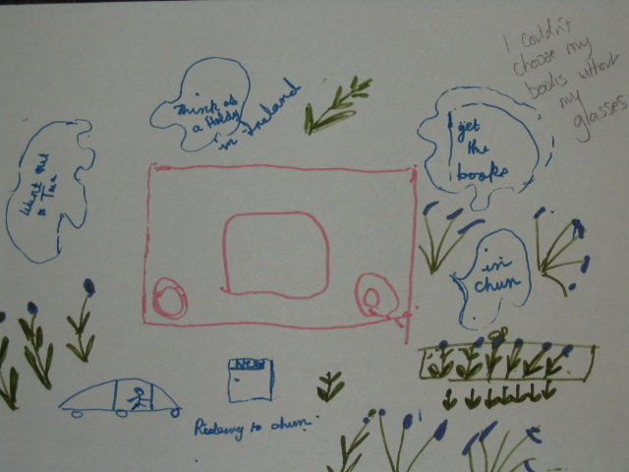

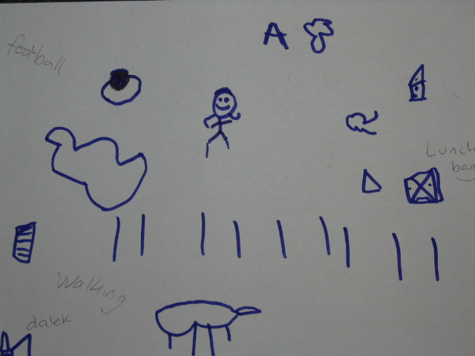

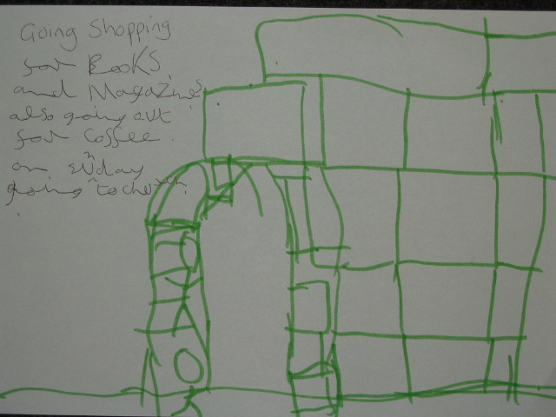

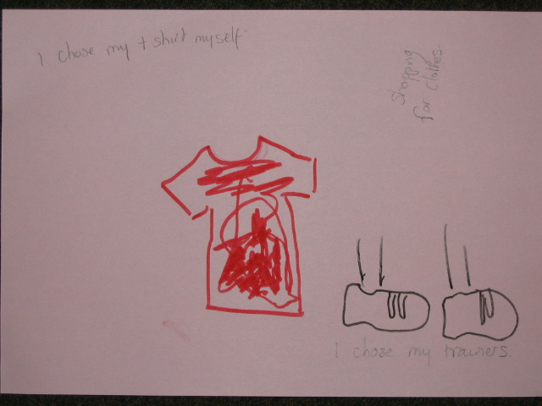

Things people said about being able to see well:

‘I can see better with my glasses – choosing magazines’

‘I couldn’t choose my books without my glasses’

‘I’ve got 2 pairs. 1 for long-distance and 1 for reading. They make it easier to walk. I have walking problems. I like to walk. They help with steps and slopes.’

‘Help with choosing my clothes.’

‘Watching TV’

Feelings About My Eye-Check
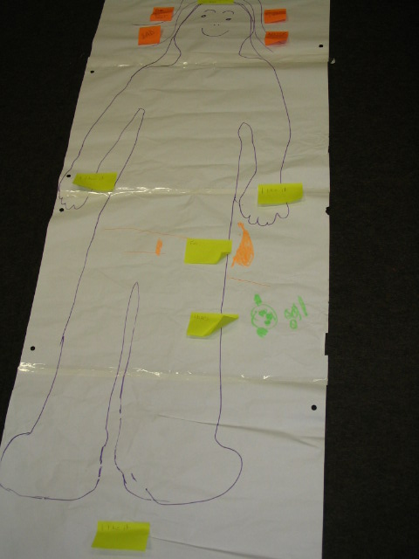
‘Bad before test’

‘ ‘ Happy to know my eyes are
good’

‘ Better after operation’

‘ I like it’ (3 people)

‘Fire’

‘Bad'

‘ Happy

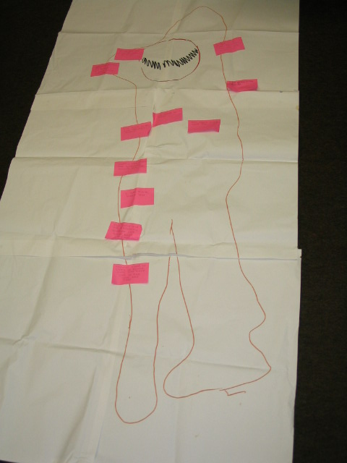
‘Good to check to make sure
you have not got sore eyes.’

‘Kathy let me ask questions about the test. Other man in Newton Abbot didn’t answer my questions. He was rather abrupt’

‘Got used to it now.’

‘I’m fine thank you’

‘Kathy did a good job’

‘I felt nervous on the first day’

‘I think it is a good thing to have your eyes checked every so often’

‘It was quite good to check you haven’t got sore eyes’

‘Alright. A good thing. Nervous.

Easier To Understand Information

- Invitation Letter – 10 people remembered this

- Photos – 5 people said the photos helped
1 person said he hadn’t seen the photos but
wished he had. He thought they were a good
idea.

- Consent form – 5 people remembered
signing this (8 months ago).

- ‘Today I Tested Your Eyes’ sheet:
4 people commented on this. 1 person didn’t
need it so threw it away. 1 person couldn’t
understand the symbols by herself, so threw it away. 1 person thought it was useful and gave it to staff. 1 person remembers Kathy giving her advice about itchy eyes. She now uses an optician in Newton Abbot.

- Out of the equipment, most people picked out the torch or having a light shone in their eyes, as the thing they remembered the best . 6 people commented with a ‘good’ sticker about this experience.

