RNIB Information & Practice Development Service
on Multiple Disability
Reprint of article from Focus 41
November 2004
RNIB's newsletter for staff working with adults
with visual and learning disabilities

Health Action Plans for people with
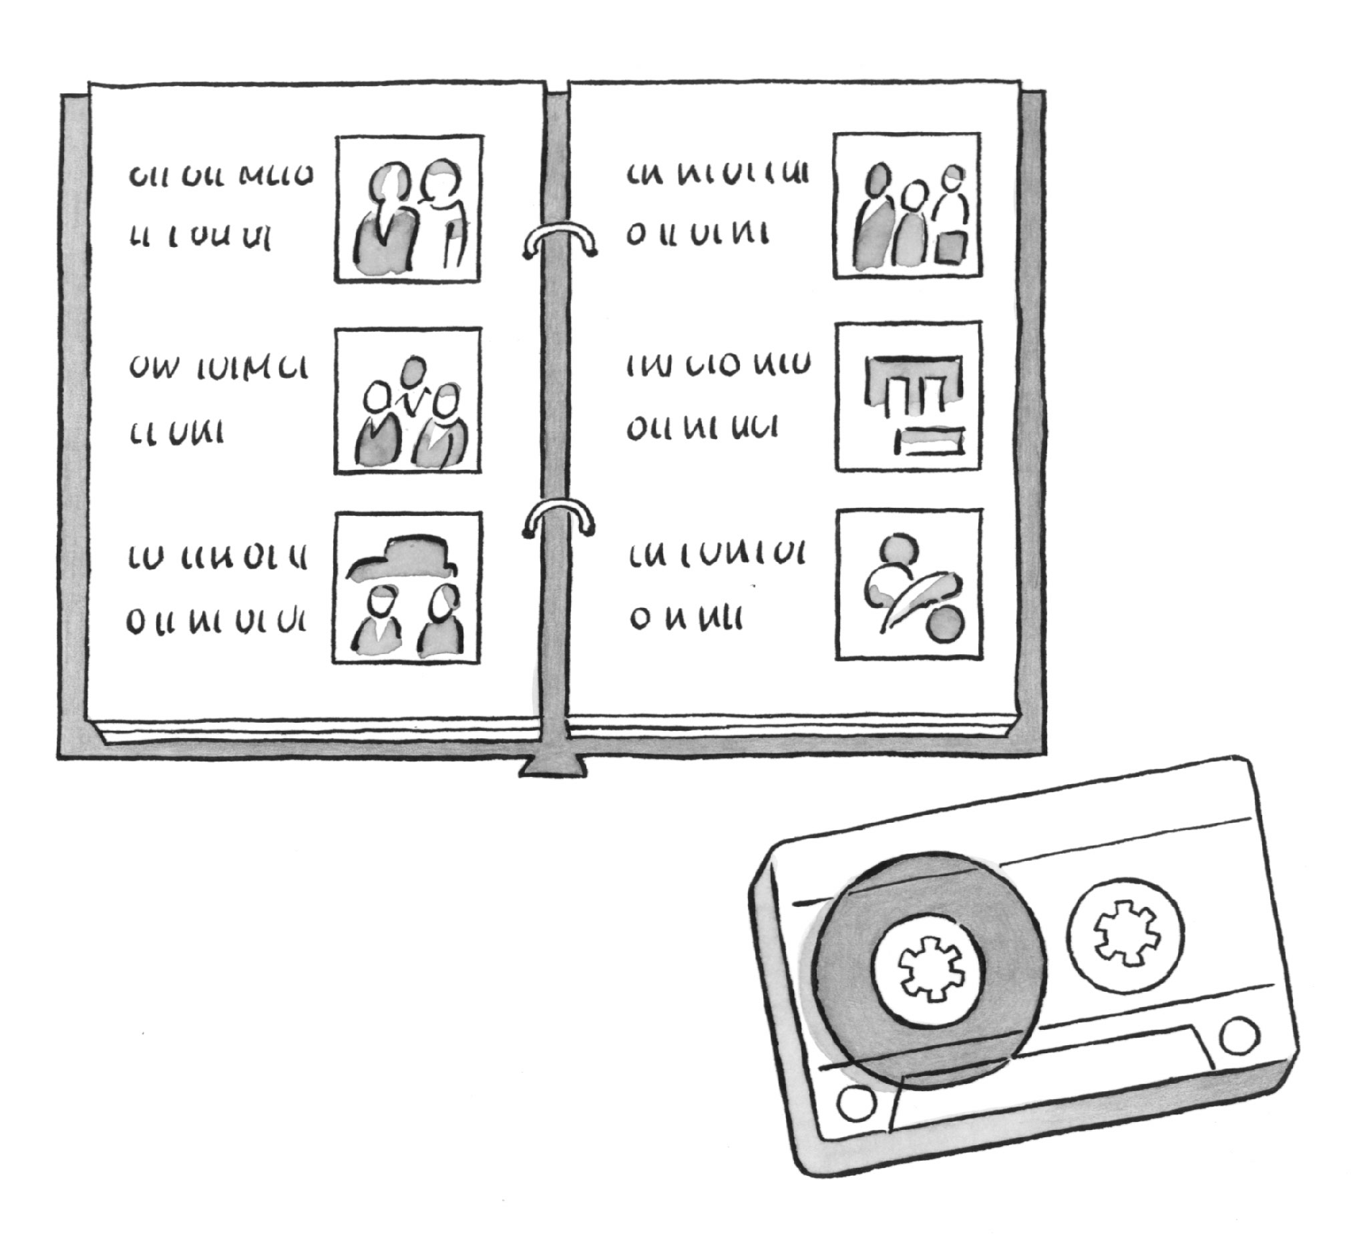
visual impairments
Laura Waite
Hope University, Liverpool

It is already widely recognised by those supporting people to develop a Health Action Plan, the importance of including information about an individual’s vision. The question still remains however, how much detail do we go into?

During a health check, with some ‘medical conditions’ it might seem sufficient to ask “Does this person have………?” with a tick box to answer ‘yes’ or ‘no’. People may even go on to ask “When was……...last checked?”.
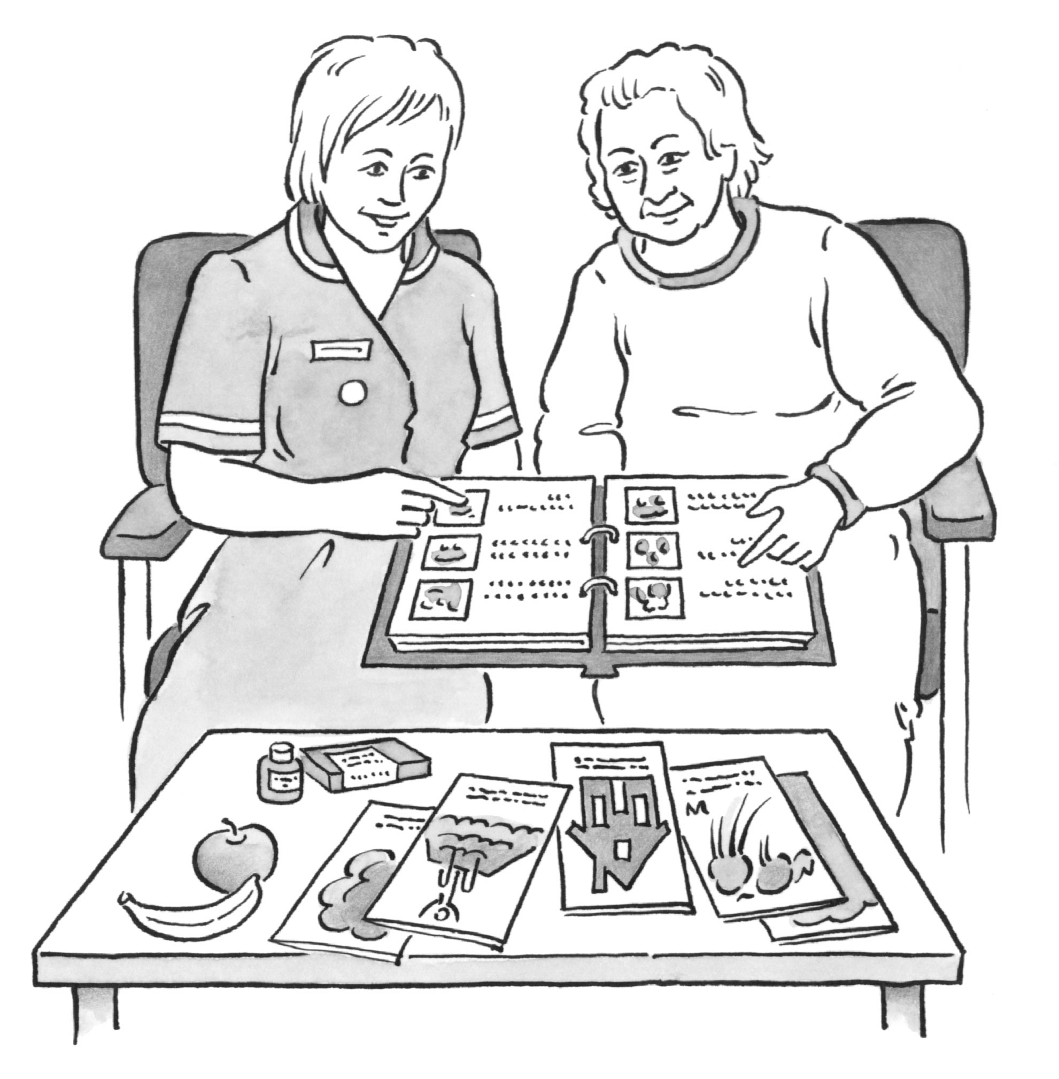

But if we consider vision and the knock on effects of this being impaired, then we might start to understand why more in depth information should be sought and documented. It is therefore, simply not enough to ask: “Do you have any problems with your vision?” and “When did you last see an optometrist?”

Why is this not enough?
Well we already know that 30% of people with learning disabilities have a significant visual impairment. We know that many people have not yet been identified as having a sight problem, it often having been perceived as part of the person’s learning disability. We can therefore assume that the moment we ask, “Do you have any problems with your vision?” the answer will be “no”.

We know that many people do not consider themselves visually impaired, either because it is something they were born with or because the difficulty lies with the brain not processing visual information effectively and therefore not so obvious to the individual.

We also know that many people still unfortunately experience barriers to appropriate eye testing. Therefore, when we ask the question “when did you last see an optometrist”, the answer may be that the person saw an optometrist only two weeks ago. Ask the question “when did you last have a thorough assessment of your vision”, then the answer may be quite different. We know that a number of eye care professionals still struggle to meet the needs of people with learning disabilities within their services.

Given the incidence of visual impairment and the fact that many people do not have the language skills necessary to communicate a change in their vision it is vital that we obtain more information about the person’s ‘behaviour’. RNIB’s Focus Factsheet: Looking for eye problems in people with learning difficulties provides a comprehensive checklist of behaviours that might indicate that someone has a visual impairment. In addition, RNIB’s Focus Factsheets: How to get the best out of sight testing for people with learning disabilities and Questions to ask the optometrist can provide useful ideas on obtaining a more successful sight test.

Why is it so important to document information on the effects of a visual impairment?
Visual impairment will affect an individual in any number of ways. However, we can safely assume that many of the affects are going to require us to change our behaviour and/or the environment.
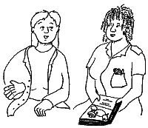
For example, a woman may have an appointment to see a dietician to obtain information on healthy eating. To ensure that she is appropriately supported to participate as much as possible in the consultation, it might be helpful if the dietician was able to read through the following:

How you can help me use my sight better.
My eyes move around quite a bit especially when I am tired so it is really helpful if my appointments are not too early in the morning or late in the afternoon. Somewhere between 11am and 2pm is best.
Say my name when you start to talk so that I know you are speaking to me.

Stand over to my left as I can see a bit better in that eye.

I should be wearing a pair of silver metal-framed glasses when I arrive (my ‘far away specs’). But if you need me to look at something close up I will need my tortoise shell plastic framed glasses (‘close up specs’).
If I need to look at something quite small, I carry a little magnifier but you might need to remind me to use this.
I find bright lights difficult so it’s helpful if there are no lamps close by my face or bright sunlight coming through the window.
I can read a little bit and prefer information to be easy words with pictures or symbols. The words are best in arial n.pt 24 font with symbols/pictures of at least 4cmsx4cms.

A person with a learning disability who has been able to provide a health professional with this basic information during an appointment is much more likely to be involved appropriately in the appointment.

It isn’t just vision that needs more documentation
Knowing how to make adaptations for someone who is visually impaired is clearly an essential consideration to make throughout the Health Action Planning process, but there are other important areas. We can’t possibly know how to interact with someone effectively if we don’t know what their level of understanding is, how they express themselves and what their hearing is like. It is therefore important to be able to also share relevant information about these skills.

This is starting to look like a communication passport
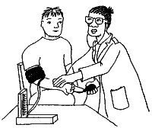
Well yes it is, but communication passports are still unfortunately
not nationally recognised ‘documents’ and Valuing People does
not state that every individual with a learning disability should have
one by 2005. Health Action Plans therefore, provide an ideal
opportunity to document crucial information on how we can best
engage with individuals.

Readers may be interested in RNIB’s Training on Health Action Planning for People with Visual and Learning Disabilities.

