This Charter has been developed on the basis of a study of over 100 families with a child with a vision impairment, carried out by Professor Mary Boulton, Oxford Brookes University; Professor Alistair Fielder, Imperial College London; Sue Clegg, Imperial College London; and Eleanor McDonald, Oxford Brookes University.

The research was funded by a grant from the Community Fund to the Royal National Institute of the Blind and the Royal College of Paediatrics and Child Health.

For further details about the study please contact:

Professor Mary Boulton
School of Social Sciences and Law
Oxford Brookes University
Oxford OX3 0BP

Email: mgboulton@brookes.ac.uk

Organisations which may be of interest to families of young children with vision impairments include:

Royal National Institute of the Blind
Helpline: 0845-766 99 99
Website: www.rnib.org.uk

LOOK - The National Federation Of Families With
Visually Impaired Children
Telephone: 0121 427 9800
Website: http://www.lookuk.cjb.net/

VICTA - Visually Impaired Children Taking Action
Telephone: 01908 632314
Email: tracie@victa.org.uk

   |  |  |  |  | 
 | 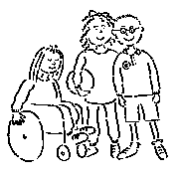  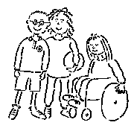 | Charter for  Families of Young Children  with Vision Impairments

This Charter is for families of young children who have a vision impairment. It was conceived within the context of the United Nations Convention on the Rights of the Child (1989) and, in the UK, the Children Act (1989) and the many initiatives to provide earlier and more integrated, responsive and comprehensive services. It aims to give families, parents and, where possible, children greater confidence in working with professionals and organisations by setting out what they have a right to expect in relation to health, education and social services and society as a whole. This is fundamental to empowerment: in understanding what they have a right to expect, families, parents and children are taking the first step to realising it.

Underlying Principles

Every child is an individual and every family is unique; this should be recognised at all times.

Services should attempt to minimise the disabling effect of any vision impairment and society as a whole should also attempt to minimise the disabling effect of social and environmental barriers.

Children with a vision impairment should be valued for the contribution they make to their family, community and society as a whole.

Families and parents should be respected as active, knowledgeable participants in the care, support and education of their vision impaired children; as children get older, their views should also be sought.

Families, parents and children should be treated equally regardless of their personal backgrounds or current circumstances.

The enduring needs of children with vision impairments, their parents and families should be considered from a life long perspective.

The Rights of Parents and Families

As a parent or member of a family of a young child with vision impairment, you have a right to expect:

- that your expertise in your own child will be recognised from the start and that you will be involved as active partners in all decisions that affect you.

- that you will have timely access to diagnostic and assessment processes so that any vision or other impairments present can be identified at an early stage.

- that you will be referred swiftly to the health, education and social services appropriate for your child’s vision impairment.

- that your child’s condition, vision impairment, visual needs and progress will be explained clearly, with empathy and in ways which will promote your understanding.

- that information on all aspects of available care, support and services for vision impairment, including what they do and how to access them, will be provided as soon as possible and updated regularly.

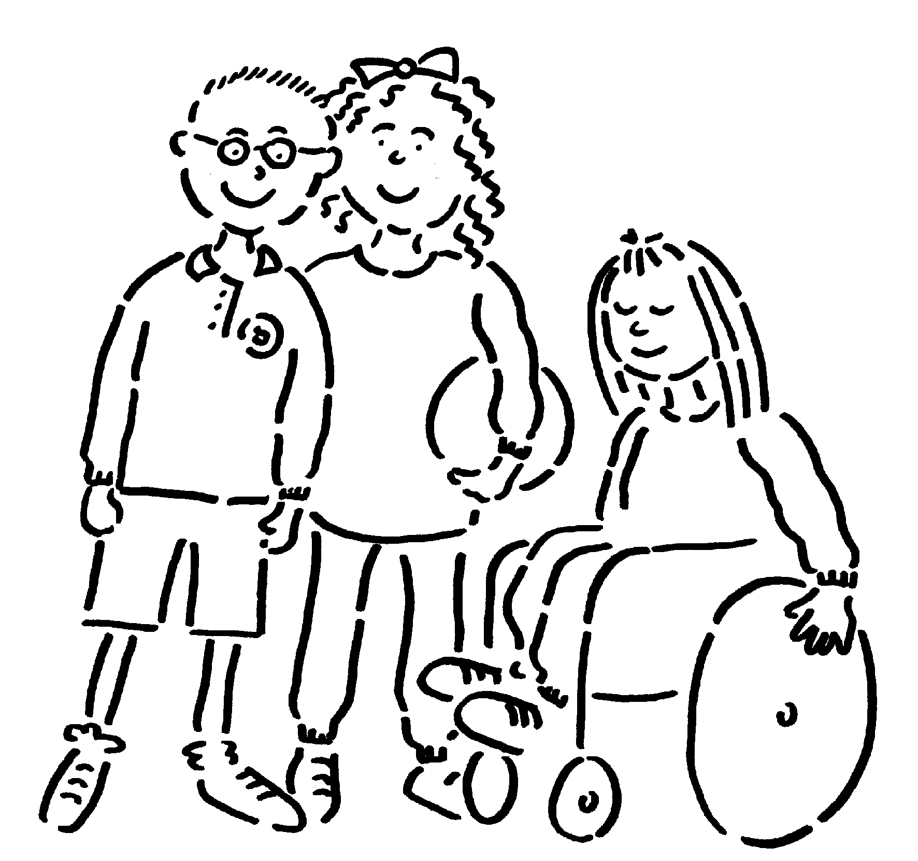

- that your child will receive the care, support and services that he or she needs as a child and as a child with a vision impairment.

- that the related needs of parents, other members of the family and the family as a whole will also be recognised and addressed in the care, support and services provided.

- that care, support and services for your child’s vision impairment will be provided within a framework which promotes communication and co-operation between professionals and continuity over time.

- that you will be directed to a range of sources of information and support for vision impairment, including specialist voluntary organisations, parent support groups and other families.

- that you and your child will have access to the same range of opportunities and life experiences as other children and families.

